Multilevel Neutral Point Clamping Double Converter for
PM Synchronous motors drive

F.BOUCHAFAA¹, E.M.BERKOUK², M.S.BOUCHERIT²

¹Laboratory of Instrumentation and engineering system. University of Science and Technology Houari Boumediene, BP N°32 EL-Alia Beb-Ezouar Algiers, ALGERIA. Fax:(213)26.621.13.41. Email: Bouchafa_f@Yahoo.fr.
² Laboratory of Process Control. Polytechnic National School Algiers. Street Hassen Badi, El Harrach, Algiers. BP N°182 ALGERIA. Fax :(213)21.52.29.73.
Email: emberkouk@Yahoo.fr, ms_Boucherit@yahoo.fr

Abstract- The aim of this paper is to give a solution to unbalance problem of the input DC voltages of nine-level NPC-VSI used in high voltage and great power applications [1]. For that, one two-level PWM current rectifier-nine-level NPC VSI-PMSM cascade is presented. In the first part, we develop a knowledge model of nine-level NPC VSI and propose a space vector modulation of this converter using eight bipolar carriers. The characteristics of this strategy are studied and the performances of the drive of the PMSM fed by this inverter are presented too [2,3]. In the first case the input DC voltages of the multilevel inverter are supposed constant and equals. After that, we propose to study a new high voltage cascade two-level PWM current rectifier-nine-level NPC VSI-PMSM. This study shows particularly the problem of the stability of the DC voltages of the inverter and its consequence on the performances of the PMSM speed control. Then, we propose a solution to the problem by employed closed loop regulation using classic PI regulator mode. We add a Clamping bridge to stabilise the eight DC input voltages of nine-level NPC VSI. This cascade found applications in great power and high voltage fields as electrical traction.
Keywords- NPC inverter, clamping bridge, rectifier multilevel, PWM strategy, regulation, enslavement.

1. Introduction
Multilevel inverter structures are becoming increasingly popular for high power applications because their switched output voltages harmonics can be considerably reduced by using several voltage levels while still switching at the same frequency. As well, higher input DC voltages can be used since semiconductors are connected in series for multilevel inverters structures and this reduces the DC voltage each device must withstand. Multilevel converters can generate near sinusoidal voltage with only fundamental switching, have almost no electromagnetic interference and are suitable for large volt ampere rated motor drives and high voltages [1,2]. Multilevel inverters have been developed to overcome shortcoming in solid state switching device ratings so that they can be applied to high voltage electrical systems [3].
Nine-level differs from two, three, five and seven-level inverters in the nature of the link voltage balancing problem. One of the major limitations of the multilevel inverters is the instability of the input DC voltages.
In this work, the authors study a new DC/AC converter nine-level NPC VSI.
They firstly propose a knowledge model of this inverter and develop a PWM strategy to control it: Space Vector modulation using eight bipolar carriers. Then, in the second part, they study the performances of the speed control of a PMSM by the field oriented control fed by the multilevel VSI supposing the input DC voltages of the inverter constant and equals. After that, they clearly show up the stability problem of the eight inputs DC voltage sources by studying a two-level PWM current rectifier-nine-level NPC VSI-PMSM cascade.
In the last part, we propose a solution to this problem by using feedback loops to regulate the total DC voltages by using to enslave it using proportional-integrator regulator and equalising the DC capacitor voltages in all the levels by using a clamping bridge.
2. Modelling and control of nine-level NPCVSI
Three phases nine levels NPC VSI is a new structure of power conversion used to feed with variable frequency and voltage, a great power alternative current machine. Several structures are possible for nine level inverters. In this paper, we study the neutral point clamping (NPC) structure (fig.1) [3]. This structure is constituted by three arms and eight DC voltages sources. Every arm has sixteen bi-directional switches, ten in series and six in parallel and two diodes DD_{i0} and DD_{i1} Which let to have zero voltage for V_{KM} (V_{KM} is the voltage of the phase K relatively to the middle point M) [3].

Fig.1. A nine-level NPC voltage source inverter structure
2.1. A working model
Several complementary laws are possible for nine-level NPC VSI. The optimal complementary law used for this converter is presented below:
$$\left\{\begin{matrix}\begin{matrix}B_{i6}={\overline{B}}_{i2} \\ B_{i7}={\overline{B}}_{i1}\end{matrix} \\ B_{i8}={\overline{B}}_{i3} \\ B_{i9}={\overline{B}}_{i4} \\ B_{i\text{10}}={\overline{B}}_{i5}\end{matrix}\right.$$
(1)
B_{is}: control signal of the semiconductor TD_{is}.
2.2. Knowledge model
In a controllable mode using the proposed complementary law, we define for each semi-conductor TD_{is} a connection function F_{is} as fellow [2,3]:
$$F_{\text{iS}}=\begin{aligned}\left\{1 \text{if} {\text{TD}}_{\text{iS}} \text{is} \text{closed} | \right.\end{aligned}$$
(2)
(2)
(i: number of the arm and s: number of the semi-conductor).
The input voltage of the inverter, relatively to the middle point M, is given by the following system:
$$\begin{matrix}V_{\text{KM}} \\ \\ \\ \\ \\ \\ \\ \end{matrix}$$
(3)
Where k=A,B,C and respectively i=1,2,3.

In order to reduce the above equation and to define a control model of the converter, we define the half arm connection function $F_{\text{i1}}^{b}$and$F_{\text{i0}}^{b}$associated respectively to the upper and lower half arms.
(4)
We define a global half arm connection function:
(5)
(5)
When$F_{\text{i1}}^{\text{bT}}$equal to 0, the upper half arm is opened, and if $F_{\text{i0}}^{\text{bT}}$equal to 0, the lower half arm is opened too. The simple voltages of three phases nine-level NPC VSI are given by the following system:
(6)
(6)
2.3. Space Vector Modulation strategies method
Other authors have extended two-level carrier-based PMWM techniques to multilevel inverters by making the use of several triangular carrier signals and one reference signal par phase. For N-level inverter, (N-1) carriers with the same frequency f_{c} and same peak to peak amplitude A_{c} are disposed such that the bands they occupy are continuous. The reference, or modulation, waveform has peak to peak amplitude A_{m} and frequency f_{m}, and it’s centred in the middle of the carrier set. The reference is continuously compared with each of the carrier signals. If the reference is greater than a carrier signal, then the active device corresponding to that carrier is switched on; and if the reference is less than a carrier signal, then the active corresponding to that carrier is switched off [2]. In multilevel inverters, the amplitude modulation index, m_{a}, and the frequency ratio, m_{f}, are defined as .
The principle of this strategy SVM PWM witch is similar to sub harmonic PWM except that a zero sequence (triple harmonic) voltage is added to each of the carrier waveforms. This method takes the instantaneous average of the maximum and minimum of three reference voltages $V_{\text{sref}}=(V_{a}^{},V_{b}^{},V_{c}^{})$ and substracts this value from each of the individual reference voltages to obtain the modulation waveform [2,3].
The voltage V_{offset} is given by the following equation:
$$V_{\text{offset}}=\frac{\left[\text{max}\left(V_{\text{Sref}}\right)+\text{min}\left(V_{\text{Sref}}\right)\right]}{2}$$
(7)
The new reference vectors are deﬁned as follows:
$$\begin{aligned}\left\{V_{\text{aref}}^{}=V_{a}^{}−V_{\text{offset}} | \right.\left\{V_{\text{bref}}^{}=V_{b}^{}−V_{\text{offset}} | \right.\end{aligned}$$
(8)
Figure 3 represents the simple output voltage of nine-level NPC VSI controlled by the proposed SVM strategy with eight bipolar carriers for m=9 and 12 and r=0.9. We notice that, for even values of m, the simple output voltage has symmetry relatively to the quarter of the period, and we have only odd harmonics. But for odd values of m, we have no symmetry, and then even and odd harmonics exist (fig.2). The voltage harmonics gather by families centred around frequencies multiple of 8mf (fig.2).
.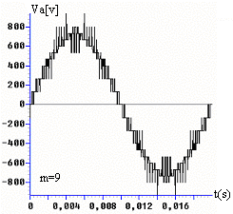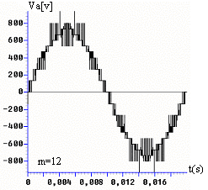
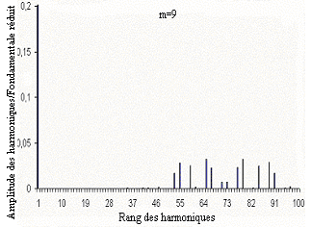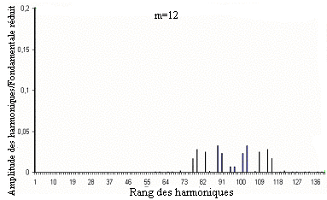
Fig.2. The simple and spectrum voltage of nine-level

3. Permanent magnet synchronous machine (PMSM) drive
The Park model of the permanent magnet synchronous machine, with P pairs of poles, is defined by the following equations system [4].
$\left[\begin{matrix}V_{\text{ds}} \\ V_{\text{qs}}\end{matrix}\right]=\left[\begin{matrix}R & −L_{q}ω \\ L_{d}ω & R\end{matrix}\right] \left[\begin{matrix}I_{\text{ds}} \\ I\end{matrix}\right]+\left[\begin{matrix}L_{d} & 0 \\ 0 & L_{q}\end{matrix}\right]\frac{d}{\text{dt}}\left[\begin{matrix}I_{\text{ds}} \\ I_{\text{qs}}\end{matrix}\right]+{ωΦ}_{f}\left[\begin{matrix}0 \\ 1\end{matrix}\right]$ (9)
The electromagnetic torque is given by the following expression.
$T_{\text{em}}=P\left[Φ_{d}I_{\text{qs}}−Φ_{q}I_{\text{ds}}\right]=P\left[\left(L_{d}−L_{q}\right) I_{\text{ds}}+Φ_{f}\right] I_{\text{qs}}$ (10)
The control strategy often used consists to maintain the current i_{ds} to zero, and to control the speed by the current i_{qs} via the voltage V_{qs}. Regulate the current i_{ds} to zero lets have, for a given stator currents magnitude, a maximum torque. In this paper, we use the algorithm i_{ds}=0 (fig.3) [5].

Fig.3. The speed control using the algorithm i_{ds}=0
4. Two-level PWM rectifier-nine-level NPC VSI-PMSM cascade
Until now, we have supposed the input DC voltages of nine-level NPC VSI constants. In this part, the authors study a generation input DC voltages manner. For these, we propose a cascade presented in the figure 4. This cascade is constituted by two-level PWM rectifier-filter intermediate-nine-level inverter-PMSM [2,3,6].

Fig.4. Two-level PWM rectifier-filter-nine-level NPC VSI-PMSM cascade

4.1. Modelling of two-level PWM rectifier
The reversibility of two-level source inverter (fig.5) allows it to work as current rectifier [3,6].
This optimal control of this rectifier is:
$$B_{\text{i1}}={\overline{B}}_{\text{i0}}$$
(11)
With i=1,2 and 3.

Fig.5. Two-level VSI converter topology

The input voltages of two-level PWM rectifier are defined as follow:
(12)
The rectifier output current is given as follows:
$$I_{\text{rect}}=F_{\text{11}}I_{\text{net}1}+F_{\text{21}}I_{\text{net}2}+F_{\text{31}}I_{\text{net}3}$$
(13)

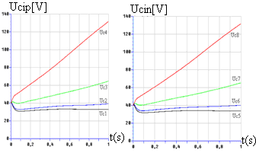
Fig.6. The different input DC voltage source intermediate

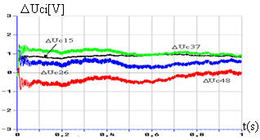
Fig.7. The difference ΔU_{Ci} of different input DC voltages

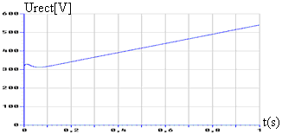
Fig.8. Output DC voltages of two-level PWM rectifier

We note the instability of the output voltage (fig.6) [3,6]. We note that, the upper input DC voltages of the inverter Uci_{(i=1÷8)} are practically not equals to the lower one. This fact accentuates the problem of unbalance of different input DC voltages sources of nine-level NPC VSI.
Figure 7 shows that the different input voltages of the VSI are not equals by pairs (U_{c1}≠U_{c5}, U_{c2}≠U_{c6}, U_{c3}≠U_{c7} and U_{c4}≠U_{c8}) and their differences (U_{c1}-U_{c5}, U_{c2}-U_{c6}, U_{c3}-U_{c7} and U_{c4}-U_{c8}) are weak. We note the instability of the output voltage of PWM rectifier (fig.8).

5. Control of input DC voltages of multilevel NPC inverter
To remedy to the problem of the instability of the output DC voltage of the PWM rectifier [7], we propose to use a clamping bridge, and regulation of the input DC voltages of multilevel inverter.
5.1. Modelling and control of clamping bridge
The clamping bridge cell is a simple circuit constituted by a transistor and a resistor in series linked in parallel with capacitor as shown in figure 9. The transistors are controlled in order to maintain different voltages equals [3,7].

Fig.9. The clamping bridge cell

To control the transistor, we propose the following algorithm:

(14)

5.2. DC link and current controller with using PI regulator
In the second part, we propose to enslave it using feedback linear control as shown in figure 10. We have observe then the application of the enslavement algorithm for a cascade constituted by two-level PWM rectifier-clamping bridge-nine levels NPC VSI.[8].

Fig.10. Synoptic diagram of two-level PWM rectifier

The synoptic diagram of two-level PWM current rectifier control is given in figure 11. As we can see on this scheme, this control is composed by two loops. The ﬁrst is the network current I_{neti}. The second one concerns the voltage loop control of the voltage U_{cm}.
5.2.1. Current controllers
Each phase k (k=A,B or C) of the three phases network feeding the rectiﬁer considered can be represented by a R_{s} and L_{s} [2,7,8].
Where N_{netλ}, i_{netλ}, and V_{KN} are respectively source voltage, line current, and rectifier input voltage, and R_{s} and L_{s} are the resistance and the inductance, respectively.
We control the network current of the phase 1,2 and 3 by proportional-Integral regulator [2,8], the algorithm of this current loop is given in figure 11 In this scheme, the transfer function G_{I}(S) is expressed as follows:
$$G_{I}(S)=\frac{\frac{1}{R_{S}}}{1+\frac{L_{S}}{R_{S}}\text{.}S}$$
(15)

Fig.11. Control algorithm of the network current of PWM rectifier

5.2.2. DC Voltage control loop
The modelling of this loop is based on the principle of the instantaneous power conservation with no loss hypothesis. This loop imposes efficient network current [7,8].
Fig.13. Enslavement algorithm of output voltage of two-level rectifier

Input and output power:
$\left\{\begin{matrix}P_{e}=\sum_{λ=1}^{3}{(V_{\text{net}λ}i_{\text{net}λ}−Rs{\text{ i}}_{\text{net}λ}^{2}−\frac{Ls}{2}\frac{{\text{di}}_{\text{net}λ}^{2}}{\text{dt}})} \\ \\ P_{s}=(U_{\text{rect}}\text{.}I_{\text{rect}})=U_{\text{cm}}(i_{c}+i_{\text{load}})\begin{matrix} & \end{matrix}\end{matrix}\right.$
(16)
Using of the power conservation principle and neglecting of joules loss in the resistor R_{s}, and we suppose the network currents sinusoidal and in phase with corresponding voltage V_{netλ}, we can write:
$${\text{3V}}_{\text{eff}}I_{\text{eff}}=U_{\text{rect}}(i_{c}+i_{\text{load}})$$
(17)
The voltage loop model of two-level rectifier is shows by figure 12.

Fig.12. Two-level rectifier voltage model

In this scheme, the transfer function G_{V}(S) is expressed as follows:
$G_{V}(S)=\frac{1}{C^{'}\text{.}S^{}}$
(18)
We use a regulator PI for voltage; the general principle enslavement of two-level rectifier is given by figure 13.

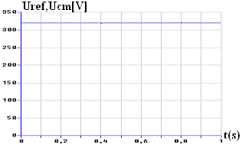
Fig.14. Output voltage of two-level rectifier and its reference

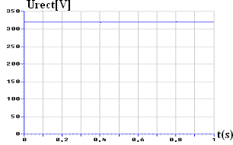
Fig.15. Output DC voltages of two-level PWM rectifier

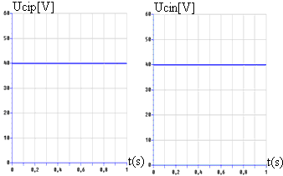
Fig.16. Output DC voltages of intermediate filter

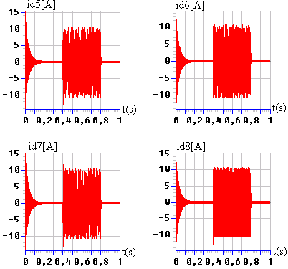
Fig.17. The input currents of nine-level inverter
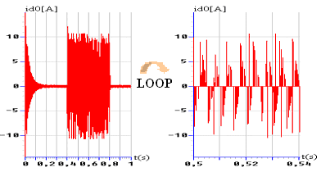
Fig.18. The input current i_{d0} of the inverter

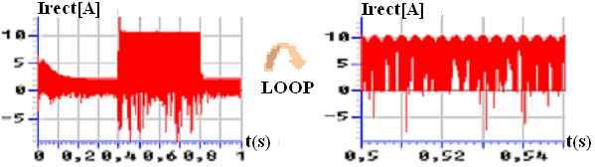
Fig.19. Output currents I_{rect} of PWM rectifier

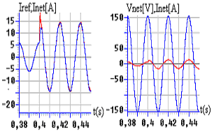
Fig.20. The network currents I_{net}, its reference and its voltage V_{net}

5.3. Application of feedback linear control algorithm of rectifier for the proposed cascade
We use the algorithm enslavement elaborated previously (fig.13) to control the rectifier of the cascade for with applied the load variation between two instants t=0.4s and t=0.8s.
Figures 14, 15 and 16 shows the simulation results when we use a full clamping bridge and feedback control with PI regulator. We note that, the output voltage of two-level PWM rectifier follows perfectly its reference which is constant and stable (fig.14). We show the performances of the feedback linear control of the output voltage of two-level PWM rectifier (fig.15). We observe that the differences between the input voltages of nine-level NPC inverter are decreased to have a value practically null in steady state, so the different input DC voltages of nine-level NPC VSI are constant and practically equal by pairs too. (U_{C1}=U_{C5}, U_{C2}=U_{C6}, U_{C3}=U_{C7} and U_{C4}=U_{C8}) (fig.16). In consequence the output voltage of the nine-level NPC VSI is symmetrical.
The currents i_{d1}, i_{d2}, i_{d3}, and i_{d4} are respectively the opposite of the currents i_{d5,} i_{d6}, i_{d7}, and i_{d8}. (fig.17). The inverter current i_{d0} has a mean value practically null (fig.18). The output voltages of two-level rectifier i_{rect} are constant (fig.19).
We remark that the network currents i_{neti} feeding rectifier follow perfectly their sinusoidal references (fig.20).The network voltage and current are in phases then the power factor of network is uniting (fig.20).
The performances of the speed control algorithm of the PMSM (fig.21). The PMSM is drive using vector control with direct current reference null.
The figure 21 shows the current i_{ds} is practically null, the speed follows quietly its reference, and the current i_{qs} and the torque are practically proportional.

Fig.21. The PMSM performances fed by nine-level NPC inverter Cascade

6. Conclusion
The present contribution intends to demonstrate that permanent magnet synchronous machine control based by field orientation when applied with one two-level PWM current rectifier-nine-level PWM NPC-VSI cascade.
In the first part, we have developed a knowledge model of a nine-level NPC VSI and have presented a space vector strategy using eight bipolar carriers. In the second part, we have studied the performances of the speed control by field orientation control of the PM synchronous machine fed by a nine-level NPC VSI.
In the first case, the input DC voltages are constants and in the second case the input DC voltages are generated by the one two-level PWM current rectifier. By this study, we have particularly shown the problem of the middle point of DC voltages source supplied the nine-level VSI and its effects the serious problems of the speed control of PMSM and the output voltages source of the nine-level inverter is asymmetric.
In the last part of this paper, we propose a solution to this problem to use a clamping bridge and enslave it using prtoportional-intergral regulator.
The application of the enslavement algorithm of the output voltage of rectifier to the cascade constituted by two-level rectifier-nine-level NPC VSI-PMSM with clamping bridge, shows parfait following of the output of rectifier and his reference and the stability of the input voltage of nine-level NPC inverter. Then, we have shows by this study the realisation AC/DC/AC cascade possibility of output bridge multilevel inverter absorbing a network current less pollute possible with a power factor of network practically unite. That, we have shows is possible to conceiver, with frequency charger using in output the nine-level inverter, PMSM variator with feeble rate of harmonics, a power factor of network unity and great charge dynamics performance.
The results obtained with this solution confirm the good performances of the proposed solution and promise to use the inverter in high voltage and great power applications as electrical traction.
References
1. A.Nabae, I.Takahashi, H.Akagi, "A New Neutral Point Clamped PWM Inverter", IEEE transaction on Industry Applications, Vol. IA-17, N°.5, pp.518-523, September/ October 1981.
2. E.M.Berkouk and al. "High voltage rectifiers-multilevel inverters cascade. Application to asynchronous machine field oriented control", IEEE conference, Stockholm, June 1995.
3. F.Bouchafaa, E.M.Berkouk and M.S.Boucherit, "Analysis and simulation of a nine-level Voltage Source Inverters. Application to the speed control of the PMSM", Electromotion Journal. Vol.10, N°.3, PP.246-251, July-September 2003.
4. P.Pillay and R.Krichman,"Modelling, simulation and analysis of permanent magnet motor drives, Part I the PMSM derives", IEEE Transaction on industry applications, Vol.25, N°.2, March/April 1989.
5. Y.Fu and al. "Digital control of a PM synchronous actuator drive system with a good power factor", IMACS'91 world congress, Dublin, July 1991.
6. N.Hor,J.Jung and K.Nam, "A Fast Dynamic DC Link Power-Balancing Scheme for PWM Converter-Inverter", IEEE. Transactions on Industrial Electronics, Vol.8, N°.4, August 2001.
7. Zh.Peng and J.Sh.Lai, "Dynamic performances and control of a static VAR Generator Using Cascade Multilevel Inverters", IEEE. Transactions on Industry Applications, Vol.33, N°.3, May/June 1997.
8. R.Strzelecki, C.Benyesek and J.Rusinski "Analysis of DC Link Capacitor Voltage balance in Multilevel Active Power Filters" European power Electrical, 2001-Gratz.

